Instructions for the Application form: Compute component of the Flemish Tier-1 supercomputing platform.

- Research project within the framework of which computing time is applied for. Provide
  - title,
  - supervisor(s) and their e-mail address,
  - if available, IWETO or FRIS link,
  - and financing institution or channel (FWO, BOF, VLAIO, EU, etc.).
Attach the confirmation letter as enclosure.
Attach a letter of approval of your own institution in case the project has not gone through a scientific approval process.

- Include a short description of your research project, in layman’s terms wherever possible, with a view to dissemination. Explicitly mention the scientific questions that you are planning to address, referring to the computational tasks described in Q7, and the overall scientific goals of this proposal. (max. 1 A4 in Arial 12)

- Persons mandated by the Applicant to compute on the Tier-1 within the framework of the present project. Please provide for every person:
  - Name, first name
  - VSC id
  - Institution
  - Research group / department:
  - Experience with using particular HPC resources (i.e. Tier-0/Tier-1/Tier-2 infrastructure) in Belgium and abroad. Specify both the name of infrastructure and number of years it was used.
  - List of computing time allocations received during the past two years, on the Flemish Tier-1 systems, as well as other Tier-1 and Tier-0 systems.

- Why does this project need to run on a Tier-1 system, rather than Tier-2 or Tier-0? Motivate your answer.

- Provide information for each software package that will be used.
  - If centrally installed on Tier-1 compute or a Tier-2 system within VSC, state the module name and system name.
  - If not open source software, state that the associated license can be validly used by all mandated users on Hortense. Add a copy of the signed license to this application.

- Provide the results of parallel efficiency tests for each software package that will be used.
  - Perform these benchmark tests on the targeted Tier-1 system (using, e.g., a Starting Grant).
  - Use system/problem sizes that characterise those of the intended computational tasks (e.g., same mesh size, actual molecular system, similar I/O pattern, same communications patterns, etc.). If a different system/problem size is used in the tests, you must describe how it relates to the problem size in the application. Characteristic I/O must be included in the tests. For example, simply run your application tasks for a limited number of iterations.
  - List the results in a table and plot efficiency versus number of cores or number of GPUs using a log scale x-axis (see example Tables 1 and 2 and Plots 1 and 2).
  - Start the scaling tests of your code using the smallest number of cores or GPUs possible. If possible, the baseline is using 1 core or 1 GPU on a dedicated node. If not possible, explicitly state why (e.g., lack of memory). This baseline is used to calculate the strong scaling parallel efficiencies.
  - Mention on which partition the tests were run: cpu_rome, cpu_rome_512, cpu_milan, gpu.
  - Wall clock times are preferably obtained by averaging the timing results of several similar simulations for each node/core/GPU configuration. This is required for task farming jobs as they can vary significantly in run time. In that case, give an indication of variation (e.g., standard deviation).
  - When benchmarking on GPUs, the timing for a run on a CPU node should also be reported (when a CPU version of the code is available) to assess the speedup obtained by computing on GPUs. Report the timings when using the CPU node exclusively and indicate the most efficient number of cores (see example Table 3).
  - Task loads that don’t use the maximum number of cores/GPUs per node are preferentially packed together, using the worker framework, e.g., atools. If the maximum number of cores cannot be used because of issues of resource contention, this should be mentioned explicitly. In all cases justify the number of resources allocated to a single job: test the impact of using a higher number of cores or GPUs for a single job.
  - Explain anomalies in plot and table.
  - In case your code scales beyond one node, clarify which number of nodes and cores/GPUs you plan to use for your computational tasks (cf. Q7) and explain why. Do this based on the strong scaling parallel efficiency plot and table (see example Table 1), . The requested amount of compute time hours must be explicitly derived from these scaling results. Parallel efficiency should be at least 50% in competitive calls.

  - In case your code cannot use the resources of more than one node (e.g., no MPI version available, or target simulation does not scale to 128 cores), weak scaling tests are expected. Select the smallest number of cores possible. If possible, the baseline is using 1 core. If not possible, explicitly state why (e.g., lack of memory). If the target core count (with a strong scaling efficiency of at least 70%) is less than a full node, consider running multiple such jobs concurrently to fill a node. The benefit of this is to increase throughput, while ensuring this remains efficient. The relevant measure to show this is weak scaling parallel efficiency T_{one_sim}/T_{n_sims} (see example Table 4) where
    - T_{one_sim} is the wall time for the target core count and
    - T_{n_sims} the (maximum) wall time for n computations.
If the target core count is, say 4, pack n = 128/4 = 32 similar computations (128 for Hortense) into one job to run it on one node using, e.g., atools, and report the wall time.

  - In case of VASP, explicitly state both the number of bands and k-points of the target simulation. Also state the range values of NPAR, KPAR, NCORE, NBANDS investigated to determine their optimal combination. Ensure KPAR divides the number of k-points evenly. Clearly state these values used for production runs.
  - In the case of CP2K, ensure power-of-two core counts are tested.
  - In case of computing different systems (be it in chemical composition or size), provide benchmarks for all relevant system sizes, e.g., a benchmark for small, medium and large size and/or for the different compositions.
  - In case of AI models: provide data for the relevant data sets you will be using, e.g., one small, one medium, and one large data set.
  - In case of AMR codes: given the mesh is dynamically refined, describe how the dynamic load balancing challenge is addressed and, rather than the max, how many levels are activated in the different tests?

  - The default memory per core is 1970 MB on the 256 GB Rome and Milan nodes, and 3970 MB on the 512 GB Rome nodes. If you use more memory per core than the default, this should be considered in computing the “Total core-hours per task”. The factor is (estimate-of-memory-usage-per-core / default-memory-per-core). Examples:
    - A job requesting 32 cores and 32 GB of memory, requires 1 GB per core, so less than the default. Factor = 1.
    - A job requesting just 1 core but all the memory of a 256 GB Rome node, effectively uses all cores of that node. Factor = 128.
    - A job requesting 32 cores and 96 GB of memory, requires 3 GB per core. This is more than the default of 1970 MB on the 256 GB nodes but fits within the default of 3970 MB on the 512 GB nodes of cpu_rome_512, so factor = 1. If the job needs to run on the cpu_milan partition, the factor becomes 3072 / 1970 = 1.64.
    - A job requesting 32 cores and 160 GB of memory, requires 5 GB per core, so more than the default of 3970 MB on the 512 GB nodes. Factor = 5120 / 3970 = 1.29. If the job would run on the 256 GB nodes, the factor becomes 5120 / 1970 = 2.65, so you’re advised to choose the most optimal partition for your job.
If you don’t specify memory requirements in your job script, the factor will be 1.

Example Table 1 (CPU – strong scaling)
Number of nodes | Total number of cores | Wall clock time (s) | Speed-up  (w.r.t. baseline) | Efficiency
Abaseline | Bbaseline | Cbaseline | 1.00 | 1.00
A1 | B1 | C1 | C_{baseline}/C1 | (Bbaseline*Cbaseline)/(B1*C1)
A2 | B2 | C2 | C_{baseline}/C2 | (Bbaseline*Cbaseline)/(B2*C2)
Baseline = minimal configuration with which your computational task can be carried out on Tier-1.
Wall clock time is difference between start/end of the computational task, including any I/O operations as part of that task.

Number of nodes | Total number of cores | Wall clock time (s) | Speed-up  (w.r.t. baseline) | Efficiency
1 | 1 | 200000 | 1,00 | 1,00
1 | 32 | 6300 | 31,75 | 0,99
1 | 64 | 3161 | 63,27 | 0,99
1 | 128 | 1597 | 125,24 | 0,98
2 | 256 | 850 | 235,29 | 0,92
4 | 512 | 460 | 434,78 | 0,85
8 | 1024 | 250 | 800,00 | 0,78
12 | 1536 | 180 | 1111,11 | 0,72
16 | 2048 | 150 | 1333,33 | 0,65
32 | 4096 | 90 | 2222,22 | 0,54
64 | 8192 | 55 | 3636,36 | 0,44

Example Plot 1 (CPU – strong scaling)
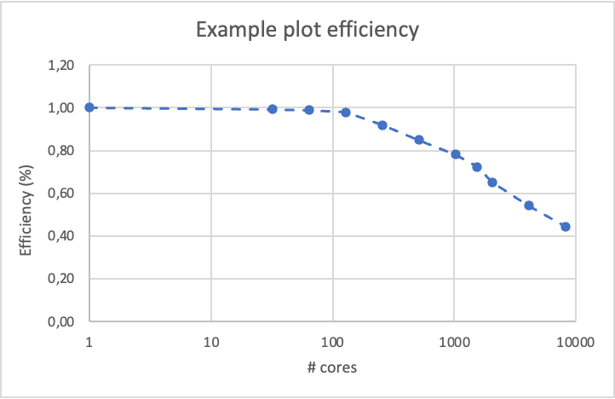

The optimal number of cores in this example is 1536, as parallel efficiency quickly drops below 70% when more cores are used.

Example Table 2 (GPU)
Number of nodes | Total number of cores | Total number of GPUs | Wall clock time (s) | Speed-up  (w.r.t. baseline) | Efficiency
1 | 12 | 1 | 692 | 1,00 | 1,00
1 | 24 | 2 | 422 | 1,64 | 0,82
1 | 48 | 4 | 215 | 3,22 | 0,80
2 | 96 | 8 | 124 | 5,57 | 0,70
3 | 144 | 12 | 83 | 8,31 | 0,69
4 | 192 | 16 | 70 | 9,89 | 0,62

Example Plot 2 (GPU)
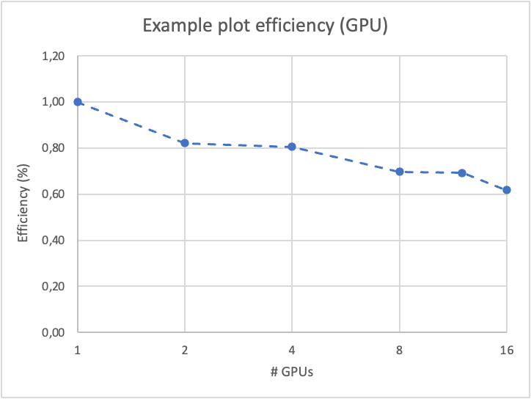

If available: timing on one CPU node, using the most optimal number of cores, of the CPU version of the code used on the GPUs.

Example Table 3 (CPU version of GPU code)
Number of nodes | Total number of cores | Wall clock time (s) | Speed-up  (w.r.t. baseline) | Efficiency
1 | 1 | 250000 | 1,00 | 1,00
1 | 32 | 10000 | 25,00 | 0,78
1 | 64 | 7000 | 35,71 | 0,56
1 | 128 | 5000 | 50,00 | 0,39

Example Table 4 (CPU – weak scaling)

Part 1: strong scaling, fraction of a node to obtain at least 70% efficiency
Number of nodes | Total number of cores | Wall clock time (s) | Speed-up  (w.r.t. baseline) | Efficiency
1 | 1 | 40000 | 1,00 | 1,00
1 | 4 | 12000 | 3,33 | 0,83
1 | 8 | 7500 | 5,33 | 0,67
1 | 16 | 6000 | 6,67 | 0,42

Part 2: pack jobs into one node and compute weak scaling efficiency
Number of jobs in 1 node | Number of cores per job | Wall clock time (s) | Efficiency
Abaseline | Bbaseline | T_{one_sim} | 1.00
A1 | Bbaseline | T_{n_sims} | T_{one_sim}/T_{n_sims}
Baseline = minimal configuration with which your computational task can be carried out on Tier-1.
Wall clock time is difference between start/end of the computational task, including any I/O operations as part of that task.

Number of jobs in 1 node | Number of cores per job | Wall clock time (s) | Efficiency
1 | 4 | 12000 | 1,00
32 | 4 | 15000 | 0,80

- Justify the number of core-hours and GPU-hours, in terms of the presented scaling/benchmarking results, and the storage volume applied for.

Describe your planned computational tasks and the sequence in which these tasks will be performed. Please refer to description in your proposal and to the relevant scaling tests and their parallel efficiency tables.
Resource estimates (wall clock time, number of nodes/cores/GPUs, estimate of memory requirement (not the target node memory), storage) should be based on the results of scaling tests on Hortense (via, e.g., a Starting Grant) for system/problem sizes that characterise those of the intended computing tasks (e.g., same mesh sizes, actual molecular system, same I/O pattern, same amount of communications, etc.). Core hours must be calculated in terms scaling test results, and not from personal experience. If you plan to run the tasks concurrently, mention this in the description, so you can specify the correct total amount of scratch space required at any given time.
Start from the examples in Tables 5 and 6 and adjust them to your project.

Note that per requested GPU-hour on Hortense, you will automatically receive 12 core-hours on the CPU cores of the node containing that GPU unit. These core-hours do not need to be specified explicitly on page 1 and in Table 6.

NB: After 3 months of the allocation time have passed, you will lose 20% of the initially granted core-hours and GPU-hours, if that 20% has not been used. (cf. regulations, § 9)

Example Table 5
 | Core-hour calculation |  |  |  |  |  |  |  |  | Storage volume estimate
Computational task | Number of such jobs | Wall clock time (in hours) per job¹ | Number  of Tier-1  nodes per job | Number  of Tier-1 cores per node per job | Memory factor (memory-per-core (MB) / default-memory-per-core²) | Total core-  hours per task* | Estimate of memory usage (GiB) per node  per job³ | Partition (cpu_rome, cpu_rome_512, cpu_milan) | OpenMP / MPI / OpenMP + MPI  (hybrid) / worker framework / atools / TorchDistributor etc. | Tier-2  DATA/HOME volume (TiB) + number of files | Tier-1 SCRATCH volume (TiB) number of files⁴ | +
Task  - software X  - parameters/conditions  - system/mesh size  - … | A | B | C | D | E | = A x B x C x ceil(D x E) | F
Task example CP2K  - CP2K – MD  - 100 ns runs  - PBE functional  - 1 -> 5 water molecules | 5 | 48 | 12 | 128 | 1 | 368640 | 64 |  | MPI | 0 TiB  0 files | 0.1 TiB  5000 files
Task example worker  - MDTraj postprocessing  - 5000 files | 10000 | 0.5 | 1 | 1 | 1 | 5000 | 1.5  (192 GiB for 128 jobs in one node) |  | These single-core jobs will be packed within 1 node using worker framework | 1 TiB  10000 files | 0.1 TiB  5000 files
 |  |  |  |  |  | Sum of core-hours applied for = … |  |  |  |  | Largest amount of scratch disk required + number of associated files at any given time (so not the grand total amount)  = …

¹ 72 hours is the maximum wall clock time for any job.
² Default memory per core: 1970 MB on the cpu_rome and cpu_milan partitions, 3970 MB on the cpu_rome_512 partition.
³ Memory limits: 252 GB (cpu_rome and cpu_milan partitions), 508 GB (cpu_rome_512 partition)
⁴ We do not ask the total number of files or volume generated during the complete project, but the maximum number at any given time. This will be (a lot) smaller than the total number or volume.
The example CP2K task consists of 5 jobs, for a molecular system containing 1 to 5 water molecules. Based on timing runs on Hortense, we found that one such job runs for 48 hours on 12 nodes, using all the cores (128) in the node. The job needs 64 GiB RAM in each node and produces 20 GiB of SCRATCH storage (1000 files). Since the 5 jobs (for the 5 listed molecular systems) will be run concurrently, 5 x 20 GiB = 100 GiB of scratch disk space is required (and 5 x 1000 = 5000 files) for the entire task.
File postprocessing with the MDTraj tool is done in the example worker task, where 10000 jobs need to run on 5000 files on the SCRATCH volume to generate 10000 files on the Tier-2 DATA volume. Each job runs on 1 core. Based on 5 timing runs on Hortense, we found that the job duration varies between 25 and 28 minutes, and memory usage is 1.5 GiB at most. To be on the safe side, we foresee 30 minutes per job (0.5 hours). Wherever possible, 128 jobs will be packed on a single node using the worker framework, weak scaling tests showed that packing 128 jobs held 100% efficiency, so 128 jobs require 1 full node for 30 minutes. For the entire task, 5000 core-hours are required.

Example Table 6
 | GPU-hour calculation |  |  |  |  |  |  | Storage volume estimate
Computational task | Number of such jobs | Wall clock time (in hours) per job¹ | Number  of Tier-1 nodes per job | Number  of Tier-1  GPUs per node  per job | Total GPU-  hours per task² | Estimate of memory requirement (GiB) per node  per job³ | OpenMP / MPI / OpenMP + MPI  (hybrid) / worker framework / atools / TorchDistributor etc. | Tier-2  DATA/HOME volume (TiB) + number of files | Tier-1 SCRATCH volume (TiB) +  number of files⁴
Task  - software X  - parameters/conditions  - system/mesh size  - … | A | B | C | D | = A x B x C x D
Task example QE  - Quantum Espresso  - 1,500 compounds  - SCF calculation | 1500 | 8 | 1 | 2 | 24000 | 106 | MPI & OpenMP | 0.4 TiB  2500 files | 1.2 TiB  7500 files
 |  |  |  |  | Sum of GPU-  hours applied for = … |  |  |  | Largest amount of scratch disk required + number of associated files at any given time  (so not the grand total amount)  = …

¹ 72 hours is the maximum wall clock time for any job.
² Per requested GPU-hour, you automatically receive 12 core-hours on the CPU cores of the GPU node. Please do not specify these core-hours in this table.
³ Memory limits: 252 GB (CPU), 40/80 GB (GPU)
⁴ We do not ask the total number of files or volume generated during the complete project, but the maximum number at any given time. This will be (a lot) smaller than the total number or volume.

The example QuantumEspresso task consists of 1500 jobs, to perform an SCF calculation on 1500 different compounds. All jobs can be executed independently of each other. Based on timing runs on the GPU nodes of Hortense, we found that one such job runs for 8 hours on 1 node, using 2 GPUs along with 24 CPU cores in the GPU node. Each job requires 106 GiB of RAM, therefore two jobs can run simultaneously on a Hortense GPU node (256 GiB). The worker framework will be used to pack 2 jobs in one job that will make sure both end up on one GPU node, optimally using all GPUs of that node. Each job generates 5 files that total 0.8 GiB. For all tasks, this amounts to 1500 x 0.8 GiB = 1.2 TiB of SCRATCH storage (7500 files). These will be regularly offloaded to the Tier-2 DATA storage in a compressed format.

- Describe how you will manage the workflow and the resources requested in the period during which the task is to be performed.

In case you will launch a large number of computational tasks, describe how you will manage your jobs and provide details regarding job management, automation and dataflow. Just submitting “manually” is not advised. Will you make use of a task/workflow manager, such as the worker framework, e.g., atools or something similar and, if so, on which infrastructure or node will this manager run? The VSC Cloud can help if you want to run dedicated infrastructure for your workflow (https://www.vscentrum.be/cloud).

Further, please present how you will manage your data. This is important, since there is no backup of the scratch file system. Describe how the transfer of files to/from Hortense will be managed and perhaps automated, and whether data reduction and/or compression of files will be performed. If available, provide information about IOPS. Also describe when you will remove checkpoints files, if applicable.

As a reminder, Tier-1 project directories will be inaccessible as soon as a project expires. Describe how you will offload, clean up and remove any remaining data in the Tier-1 project scratch folders before the project expires.

- In case you requested GPU compute time, are you interested in getting a preparatory access project on LUMI, a European pre-exascale computer (https://lumi-supercomputer.eu/), taking into account the “detailed instructions for application” on https://www.enccb.be/GettingAccess? No separate application would be required. If you answer “Yes” below, the LUMI team will contact you with further information.

☐ Yes
☐ No

- In case you develop your own code, are you interested in getting support from the EPICURE project to identify bottlenecks and potential enhancements in node and multi-node performance, to optimise or refactor code? If you answer “Yes” below, the EPICURE team will contact you with further information.

☐ Yes
☐ No

Applicants allow FWO/VSC to make this proposal in its entirety public, e.g., as an example or inspiration for other researchers.
Applicants commit to collaborate with VSC, upon its request, in the preparation of a success story (see https://www.vscentrum.be/stories).

Don’t hesitate to consult the Tier-1 Compute support (compute@vscentrum.be) or your local support (www.vscentrum.be/getintouch) when you are preparing your application.

